

# 

### Semester Two Examination, 2016

### Question/Answer Booklet

# MATHEMATICS

If required by your examination administrator, please place your student identification label in this box

**APPLICATIONS**

**UNITS 3 AND 4**

## Section One:

## Calculator-free

|  |  |  |  |  |  |  |  |  |
| --- | --- | --- | --- | --- | --- | --- | --- | --- |
| Student Number: In figures |  |  |  |  |  |  |  |  |

In words

Your name

## Time allowed for this section

Reading time before commencing work: five minutes

Working time for section: fifty minutes

## Materials required/recommended for this section

***To be provided by the supervisor***

This Question/Answer Booklet

Formula Sheet

***To be provided by the candidate***

Standard items: pens (blue/black preferred), pencils (including coloured), sharpener, correction fluid/tape, eraser, ruler, highlighters

Special items: nil

## Important note to candidates

No other items may be taken into the examination room. It is **your** responsibility to ensure that you do not have any unauthorised notes or other items of a non-personal nature in the examination room. If you have any unauthorised material with you, hand it to the supervisor **before** reading any further.

## Structure of this paper

|  |  |  |  |  |  |
| --- | --- | --- | --- | --- | --- |
| Section | Number of questions available | Number of questions to be answered | Working  time (minutes) | Marks available | Percentage of exam |
| Section One:  Calculator-free | 8 | 8 | 50 | 52 | 35 |
| Section Two:  Calculator-assumed | 13 | 13 | 100 | 97 | 65 |
|  | | | **Total** | 149 | 100 |

## Instructions to candidates

1. The rules for the conduct of examinations are detailed in the school handbook. Sitting this examination implies that you agree to abide by these rules.

2. Write your answers in this Question/Answer Booklet.

3. You must be careful to confine your response to the specific question asked and to follow any instructions that are specified to a particular question.

4. Spare pages are included at the end of this booklet. They can be used for planning your responses and/or as additional space if required to continue an answer.

* Planning: If you use the spare pages for planning, indicate this clearly at the top of the page.
* Continuing an answer: If you need to use the space to continue an answer, indicate in the original answer space where the answer is continued, i.e. give the page number. Fill in the number of the question that you are continuing to answer at the top of the page.

5. **Show** **all your working clearly**. Your working should be in sufficient detail to allow your answers to be checked readily and for marks to be awarded for reasoning. Incorrect answers given without supporting reasoning cannot be allocated any marks. For any question or part question worth more than two marks, valid working or justification is required to receive full marks. If you repeat any question, ensure that you cancel the answer you do not wish to have marked.

6. It is recommended that you **do not use pencil**, except in diagrams.

7. The Formula Sheet is **not** to be handed in with your Question/Booklet.

Section One: Calculator-free 35% (52 Marks)

This section has**eight (****8)** questions. Answer **all** questions. Write your answers in the spaces provided.

Working time for this section is 50 minutes.

Question 1 (5 marks)

(a) Re-draw the following graph to clearly illustrate that it is planar. (2 marks)

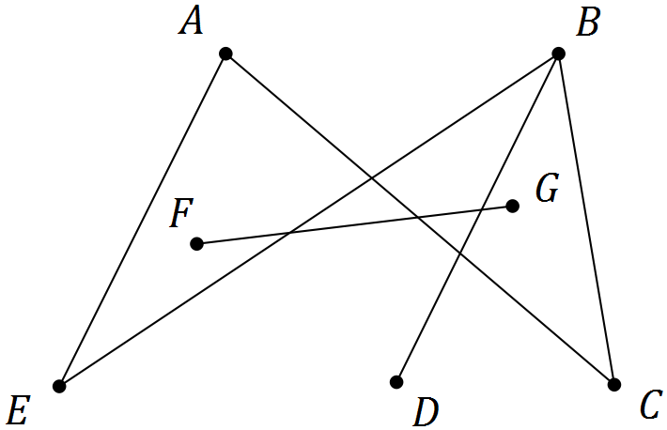

(b) A digraph is shown below.

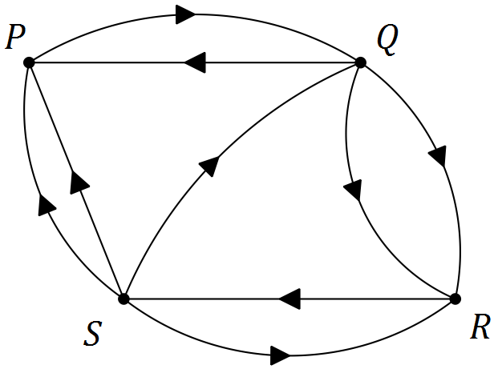

(i) Construct an adjacency matrix $M$ from the digraph. (2 marks)

(ii) Explain what information the matrix $M^{2}$ would show. (1 mark)

Question 2 (7 marks)

The number of laptop computers, $T_{n}$, that were brought to a school IT department for recharging during week $n$ of the school year can be described recursively by the rule

$$T_{n+1}=T_{n}+3, T_{4}=16$$

(a) Use the rule to complete the table below. (2 marks)

|  |  |  |  |  |  |  |  |
| --- | --- | --- | --- | --- | --- | --- | --- |
| $$n$$ | 1 | 2 | 3 | 4 | 5 | 6 | 7 |
| $$T_{n}$$ |  |  |  |  |  |  |  |

(b) Display the terms of the sequence from the table on the graph below. (2 marks)

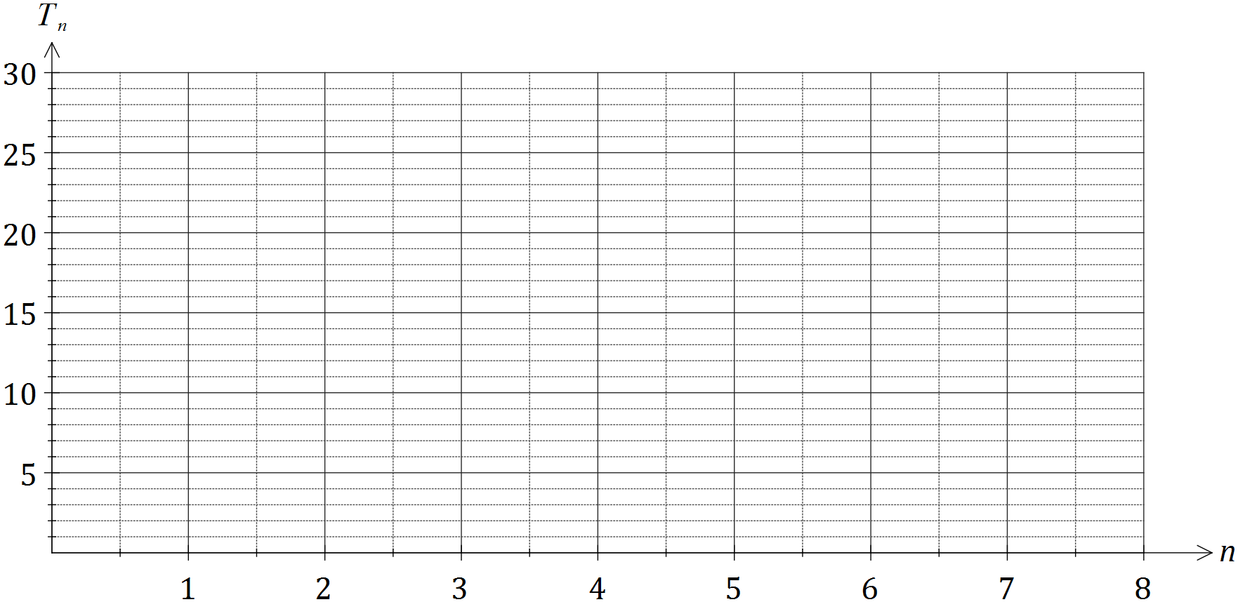

(c) A rule to determine the number of laptops brought for recharging during week $n$ can also be written in the form $T_{n}=an+b$. Determine the values of $a$ and $b$. (2 marks)

(d) If the pattern continued, determine the number of the week during which the number of laptops brought in for recharging first exceeds 50. (1 mark)

Question 3 (4 marks)

The network below shows the distances, in kilometres, between nine towns, P, Q, R, ..., X.

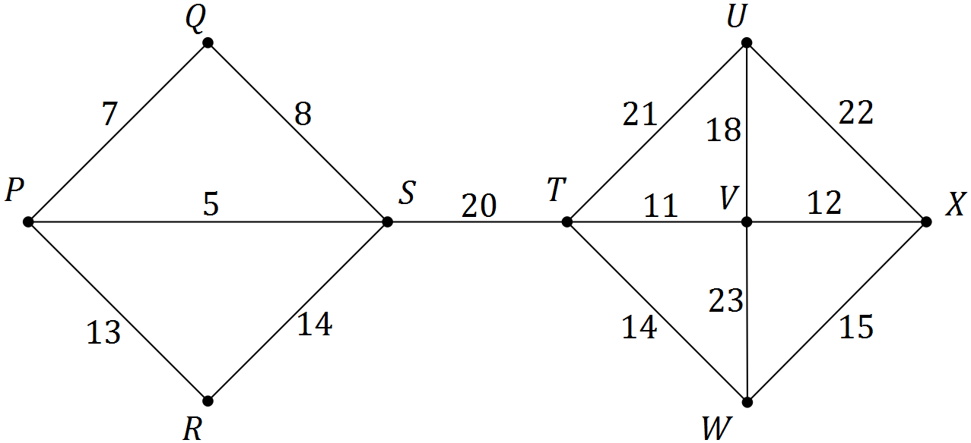

(a) Determine a minimum spanning tree for the network and draw the minimum spanning tree below. (3 marks)

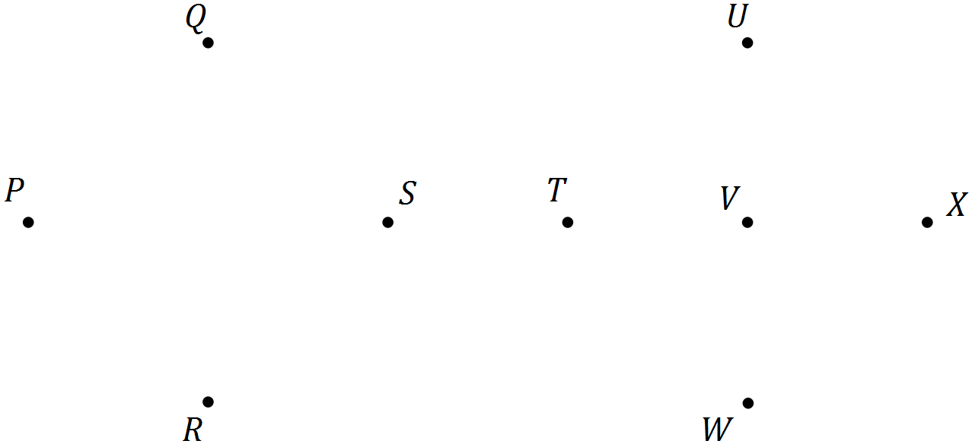

(b) State the length of the minimum spanning tree. (1 mark)

**Question 4** (7 marks)

The table below shows the number of members, $N$, of a swimming club who turned up for training over the first three weeks of winter. The club trained on Monday, Tuesday, Wednesday and Thursday each week.

|  |  |  |  |  |  |  |  |  |  |  |  |  |
| --- | --- | --- | --- | --- | --- | --- | --- | --- | --- | --- | --- | --- |
|  | Week 1 | | | | Week 2 | | | | Week 3 | | | |
| Day | M | T | W | T | M | T | W | T | M | T | W | T |
| Time, $t$ | 1 | 2 | 3 | 4 | 5 | 6 | 7 | 8 | 9 | 10 | 11 | 12 |
| Number, $N$ | 35 | 33 | 19 | 21 | 32 | 29 | 4 | 21 | 30 | 25 | 19 | 20 |

(a) Construct a time series plot of this data on the axes below. (2 marks)

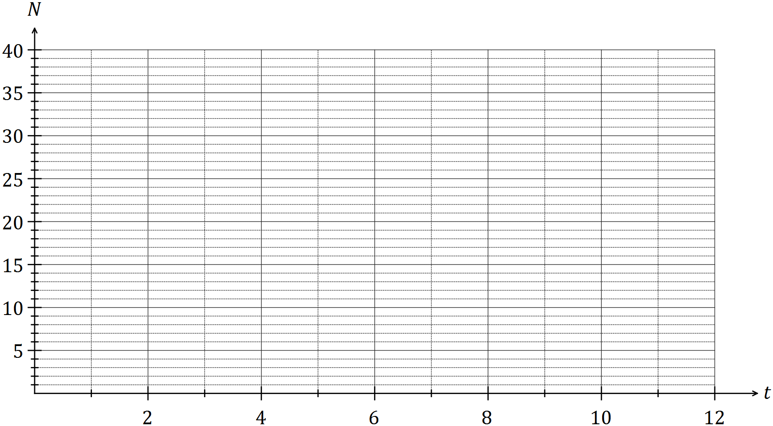

(b) Comment on features of the time series plot, including trend and seasonality. (3 marks)

(c) The trend line for the data is $N=30-0.9t$. Comment on the usefulness of this line as a short and long term trend model. (2 marks)

(d) State the days that will have the highest and the lowest seasonal index (2 marks)

Question 5 (6 marks)

(a) When collecting data as part of a statistical investigation, state a reason why a student

(i) may choose to take a sample from the population rather than a census. (1 mark)

(ii) would prefer a large sample rather than a small sample. (1 mark)

(b) A student investigated the relationship between the number of emails, $x$, and the number of text messages, $y$, received by nine people during a weekday and found that there was a weak negative linear relationship between the variables.

(i) Use the axes below to sketch a possible scatter plot that reflects this information.

(2 marks)

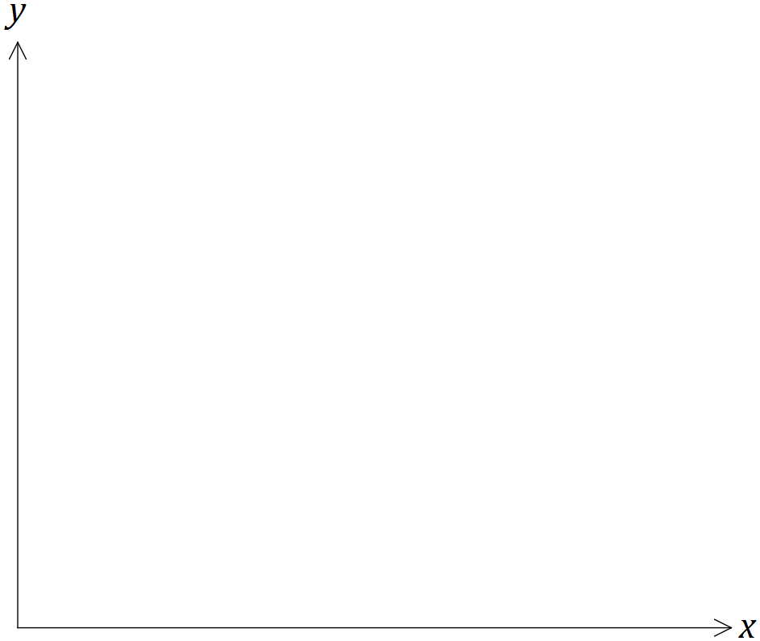

(ii) Place a cross on the scale below for the best estimate you can make for the value of the correlation coefficient between the two variables. (1 mark)



(iii) Suggest a reason for the relationship the student found. (1 mark)

Question 6 (6 marks)

(a) A simple connected graph has 4 edges and $V$ vertices. State all possible values of $V.$

(2 marks)

(b) A simple connected graph has $E$ edges and 4 vertices. State all possible values of $E.$

(2 marks)

(c) Draw a simple connected graph that has 5 vertices and is Eulerian but not Hamiltonian.

(2 marks)

Question 7 (7 marks)

The table below shows all but one of the seasonal indices for the daily sales figures for a recently opened pop-up store that is closed on Mondays and Tuesdays.

|  |  |  |  |  |  |
| --- | --- | --- | --- | --- | --- |
| Day | Wednesday | Thursday | Friday | Saturday | Sunday |
| Seasonal index | 0.65 | 0.70 |  | 1.35 | 1.50 |

(a) Determine the seasonal index for Friday. (2 marks)

(b) One weekend, the pop-up store had sales worth $3 000 on Saturday and $3 000 on Sunday. If these sales figures were deseasonalised, which day would have the highest sales? Justify your answer. (2 marks)

(c) The equation of the trend line for deseasonalised sales, $S$ in dollars, after the store had been open for $t$ days was $S=195t+1640$.

(i) Interpret the value of the slope of this line in this context. (1 mark)

(ii) Write down an expression that would forecast the actual sales of the pop-up shop on the Wednesday when $t=31$. **Do not** evaluate your expression. (2 marks)

Question 8 (8 marks)

A school has received quotes from venues A, B, C and D to host teams of students to play knockout competitions in basketball, hockey and volleyball. The four venues can only host one sport at a time and their quotes, in hundreds of dollars, for each sport are shown below.

|  |  |  |  |  |
| --- | --- | --- | --- | --- |
|  |  | Sport | | |
|  |  | Basketball | Hockey | Volleyball |
| Venue | A | 28 | 23 | 23 |
| B | 27 | 23 | 30 |
| C | 25 | 26 | 22 |
| D | 30 | 24 | 27 |

(a) If venues B, C and D are chosen for basketball, hockey and volleyball respectively, calculate the total cost. (1 mark)

(b) Represent the choice of venues for each sport as a bipartite graph. (2 marks)

(c) Show use of the Hungarian algorithm to determine a suitable allocation of sports to venues in order to minimise the total cost, and state the minimum cost. (5 marks)

Additional working space

Question number: _________

© 2016 WA Exam Papers. Kennedy Baptist College has a non-exclusive licence to copy and communicate this paper for non-commercial, educational use within the school. No other copying, communication or use is permitted without the express written permission of WA Exam Papers.